TASK 01: User Input

Write a program that takes 3 values from user. Two values of interger and one value of float data type. Print each result on one line.

Source Code:

#include<iostream>

using namespace std;

int main()

{

//declaring variable:

int a,b;

float c;

//enter a,b:

cout<<"enter any two integer value:"<<endl;

cin>>a;

cin>>b;

//enter c:

cout<<"\n"<<"enter any one float data type:"<<endl;

cin>>c;

//result:

cout<<"\n"<<a<<"\t"<<b<<"\t"<<c;

return 0;

}

Snapshot:

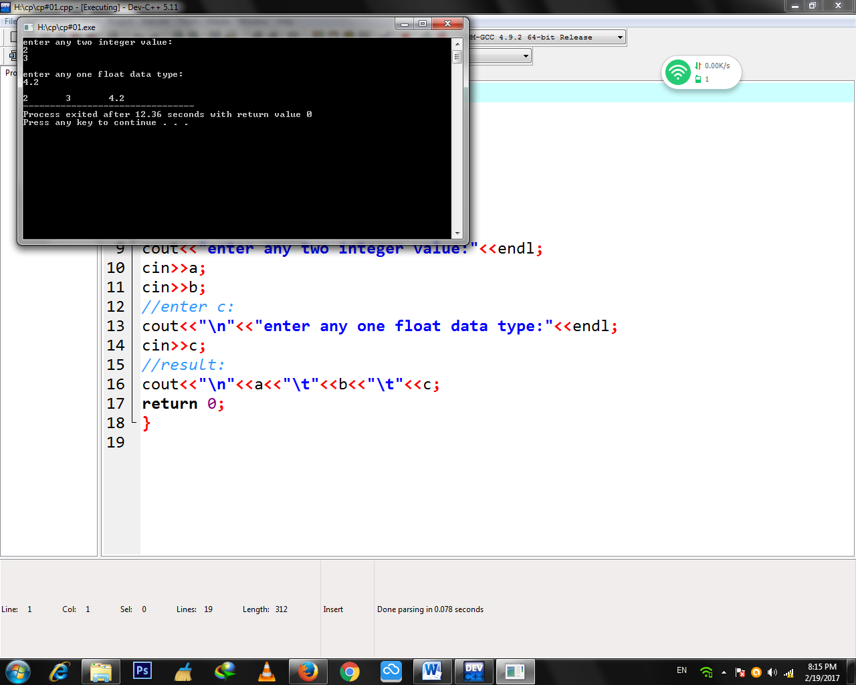

TASK 02 : Airthmetic Operations

Write a program that gets 2 integers input from user and store them in variables. Do the five basic Arithmetic Operations (+ , - , *, /, %) of the two numbers. Print the results of operations as below

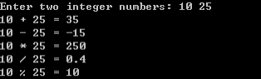

Source Code:

#include<iostream>

using namespace std;

int main()

{

//declaring variable:

float x,y,z;

//enter x and y:

cout<<"Enter any two integer numbers:"<<endl;

cin>>x;

cin>>y;

//addition:

z=x+y;

cout<<"\t"<<x<<"+"<<y<<"\t"<<"="<<" "<<z<<endl;

//substraction:

z=x-y;

cout<<"\t"<<x<<"-"<<y<<"\t"<<"="<<" "<<z<<endl;

//division:

z=x/y;

cout<<"\t"<<x<<"/"<<y<<"\t"<<"="<<" "<<z<<endl;

//multiplication:

z=x*y;

cout<<"\t"<<x<<"*"<<y<<"\t"<<"="<<" "<<z<<endl;

z=y/x;

//percentage:

z=x/y*100;

cout<<"\t"<<x<<"%"<<y<<"\t"<<"="<<" "<<z<<endl;

return 0;

}

Snapshot:

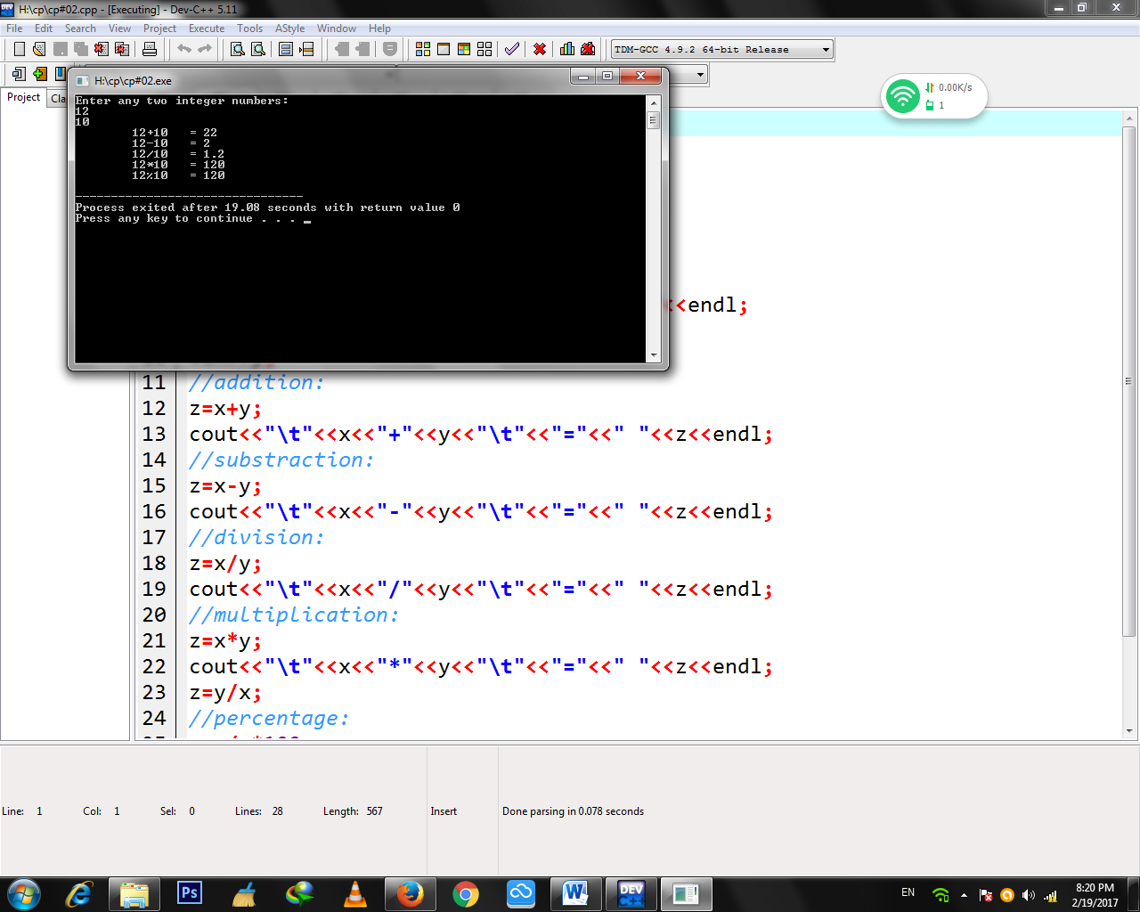

TASK 03 : Percentage

Write a program that prompt user to input course name, obtained marks and total marks. Calculate the percentage using this formula

marks percentage = marks obtained / total * 100

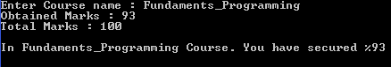and display the results as follows.

Source Code:

#include<iostream>

using namespace std;

int main()

{

//declaring variables:

float x,y,z;

//obtained marks:

cout<<"Obtained marks ="<<" ";

cin>>x;

//total mark:

cout<<"Total marks ="<<" ";

cin>>y;

//"%" in C++_Programming course:

z=x/y*100;

cout<<"\n"<<"\t"<<"In C++_Programming course.You have secured"<<":"<<z<<"%"<<endl;

return 0;

}

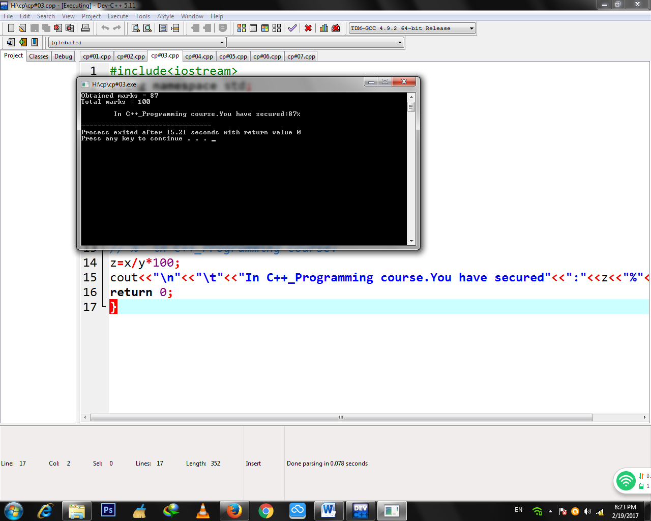Snapshot:

TASK 04 : Calculating Value of X

Write a progam that finds the value of X by using given forumula. Take value of a and b from user. X= (a + b)2 – 2ab

Source Code:

#include<iostream>

using namespace std;

int main()

{

//declaring variable:

float a,b,c,d,e,X;

//input a:

cout<<"Input value of 'a' :"<<" ";

cin>>a;

//input b:

cout<<"\n"<<"Input value of 'b' :"<<" ";

cin>>b;

//solving equation X=(a+b)2-2ab:

c=a+b;

d=c*2;

e=2*a*b;

X=d-e;

//equation solved:

cout<<"\n"<<"\t"<<"X"<<"="<<X<<endl;

return 0;

}

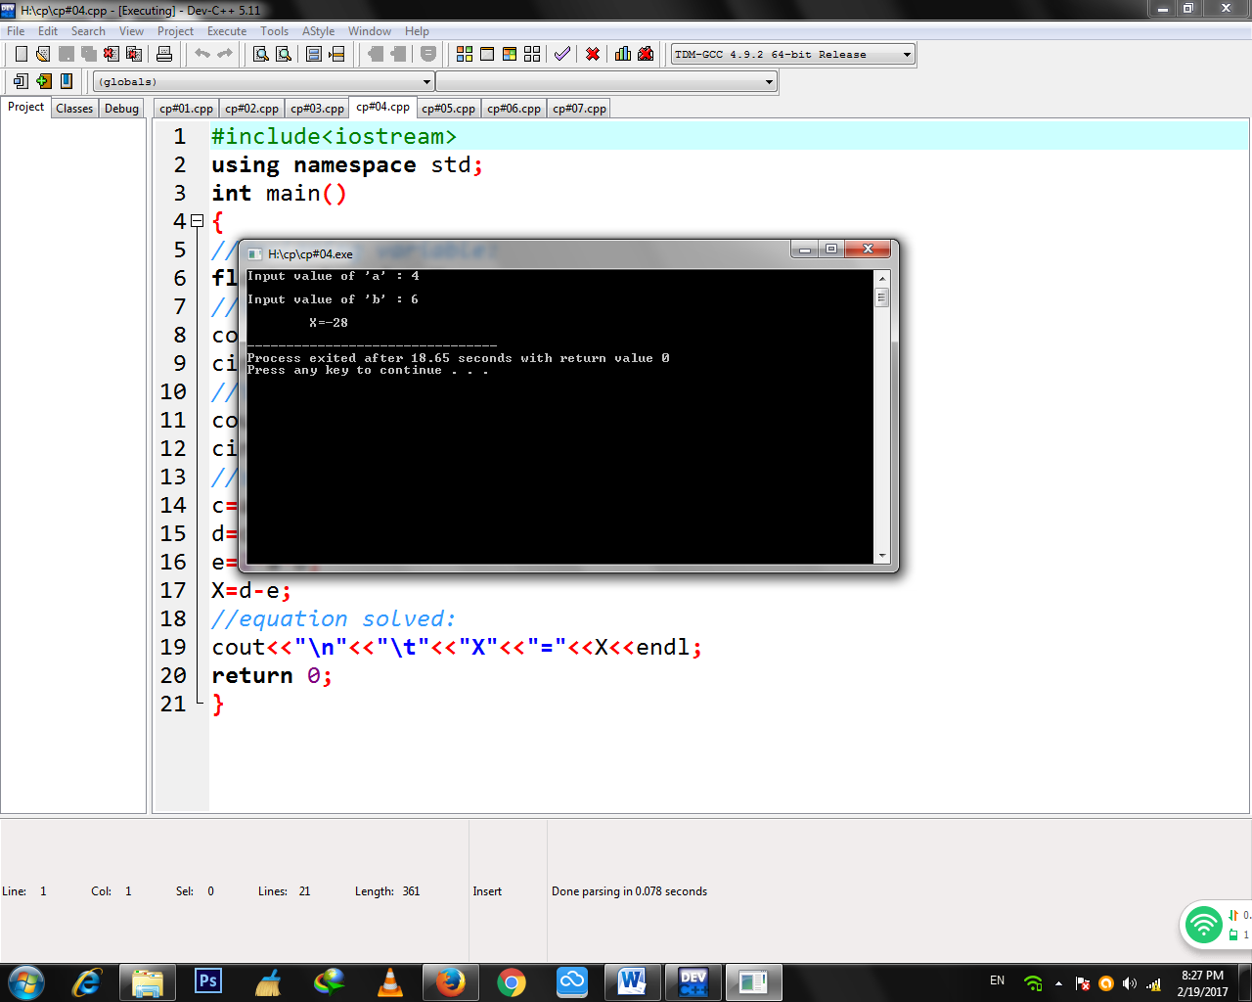Snapshot:

TASK 05 : Word Game

Write a program that plays a word game with the user. The program should ask the user to enter the following:

User’s name

Year of birth (eg. 1990)

Name of university

A favorite hobby

A pet’s name

Write a program that will produce an outcome as below:

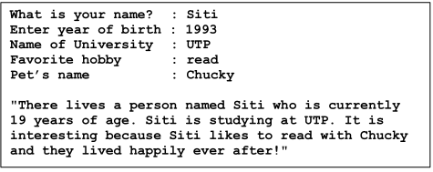

Source Code:

#include<iostream>

using namespace std;

int main()

{

//variable declare:

string name,birth,uni,hobby,pet;

//name:

cout<<"What is your name ? :"<<" ";

cin>>name;

//year of birth:

cout<<"\n"<<"Enter year of birth :"<<" ";

cin>>birth;

//university name:

cout<<"\n"<<"Name of University :"<<" ";

cin>>uni;

//favourite hobby:

cout<<"\n"<<"A favourite hobby :"<<" ";

cin>>hobby;

//pet's name:

cout<<"\n"<<"A pet's name :"<<" ";

cin>>pet;

//complete information:

cout<<"\n"<<"\t"<<"There lives a person named "<<name<<" who is currently"<<endl;

cout<<"\t"<<"19 years of age."<<name<<" is studying at "<<uni<<".It"<<endl;

cout<<"\t"<<"is interesting because "<<name<<" likes to "<<hobby<<endl;

cout<<"\t"<<" with "<<pet<<" and they lived heavily ever after!"<<endl;

return 0;

}

Snapshot:

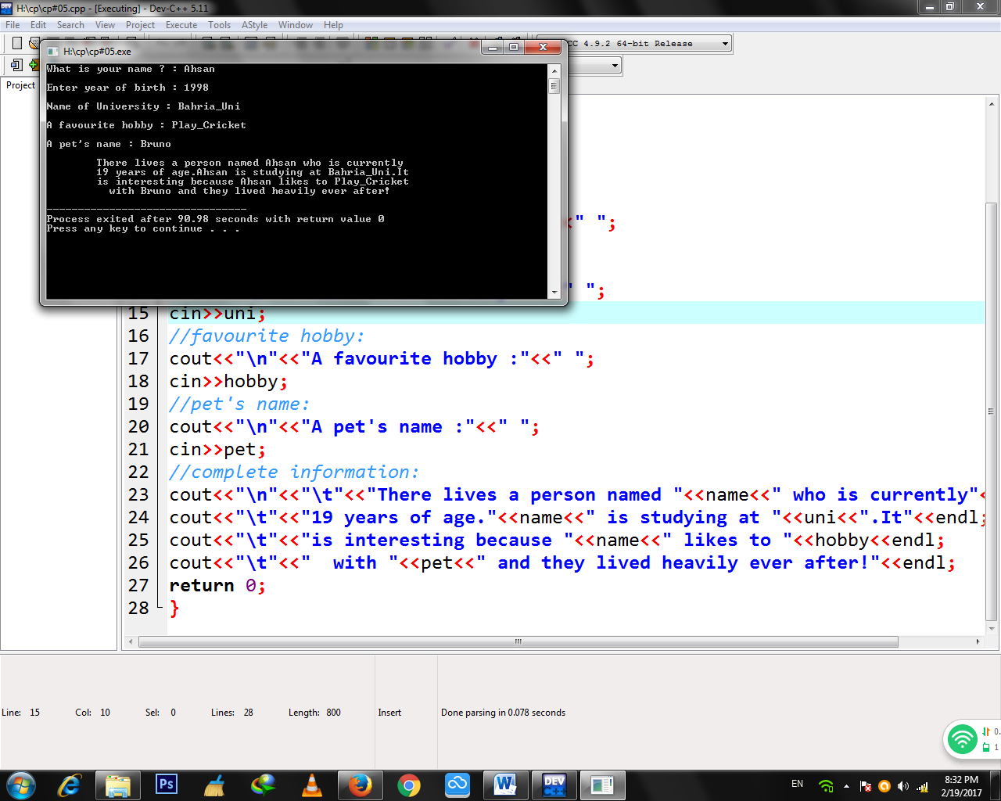

TASK 06:

Write a program that inputs a five-digit integer, separates the integer into its

individual digits and prints the digits vertically. For example, if the user types

32156, the program should print: 6

5

1

2

3

Source Code:

#include<iostream>

using namespace std;

int main()

{

//declaring variable:

char a,b,c,d,e;

//enter five integers:

cout<<"Enter any five-digit integers:"<<endl;

cin>>a;

cin>>b;

cin>>c;

cin>>d;

cin>>e;

//taking output of integers:

cout<<"\n"<<"The five-digit integers are:"<<endl;

cout<<"\t"<<a<<"\n"<<"\t"<<b<<"\n"<<"\t"<<c<<"\n"<<"\t"<<d<<"\n"<<"\t"<<e<<endl;

return 0;

}

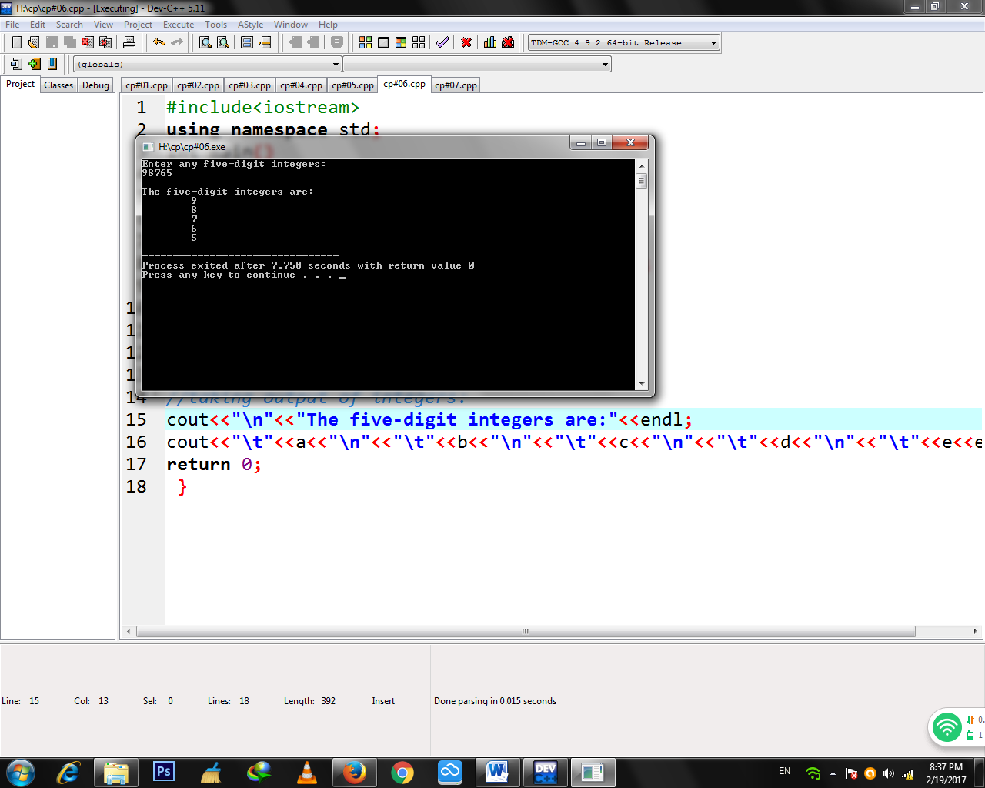 Snapshot:

TASK 07:

Hypotenuse refers to the side opposite the right angle in a right-angled triangle (as shown in the diagram below).

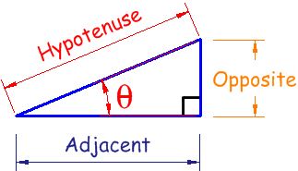

Hypotenuse can be calculated using the following formula:

h = \sqrt { x^2 + y^2 } 

Area of this right-angled triangle can also be calculated using the following formula:

a = ½ * x * y

Note that:

h= hypotenuse

x= adjacent

y= opposite

Write a C++ programm that prompt user to enter value of X and Y. You have to calculate the value of Hypotenuse (h) and Area(a).

Source Code:

#include<iostream>

#include<cmath>

using namespace std;

int main()

{

//declaring variable

float x,y,h,a,b,c,d;

//input values of x and y:

//where x=adjacent and y=opposite:

cout<<"Input value of 'x':"<<endl;

cin>>x;

cout<<"\n"<<"Input value of 'y':"<<endl;

cin>>y;

//solving eq of hypotenuse(h):

//h=(x^2+y^2)^1/2 :

a=x*x;

b=y*y;

c=a+b;

//solving eq of area(a):

//a=1/2*x*y:

d=x*y;

a=d/2;

cout<<"\n"<<"\t"<<"h"<<"="<<sqrt(c)<<endl;

cout<<"\n"<<"\t"<<"a"<<"="<<a<<endl;

return 0;

}

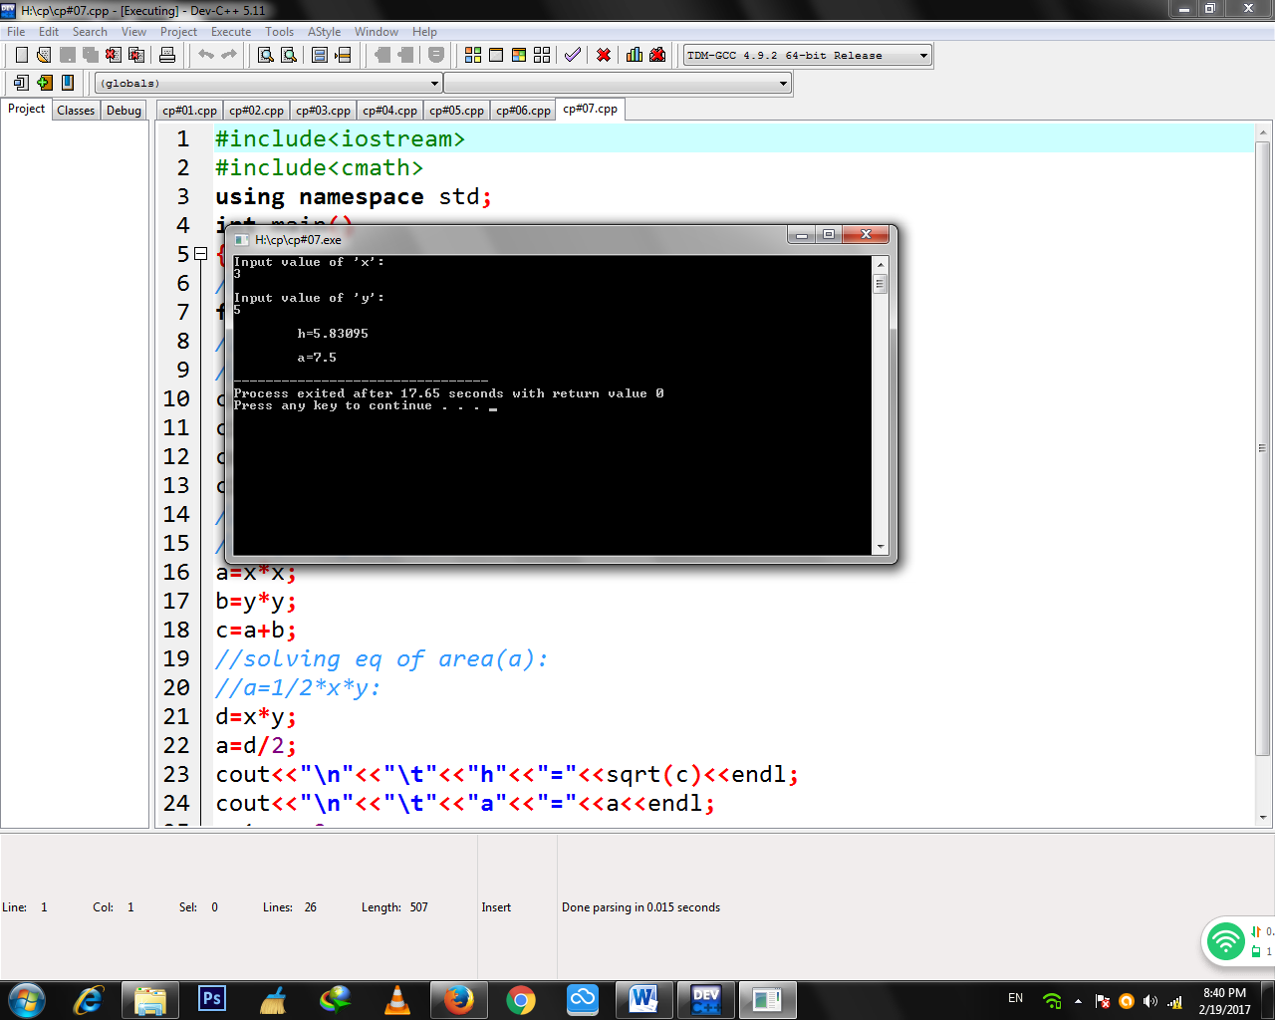Snapshot: